1. Implement and demonstrate the FIND-S algorithm for finding the most specific hypothesis based on a given set of training data samples.

Output:

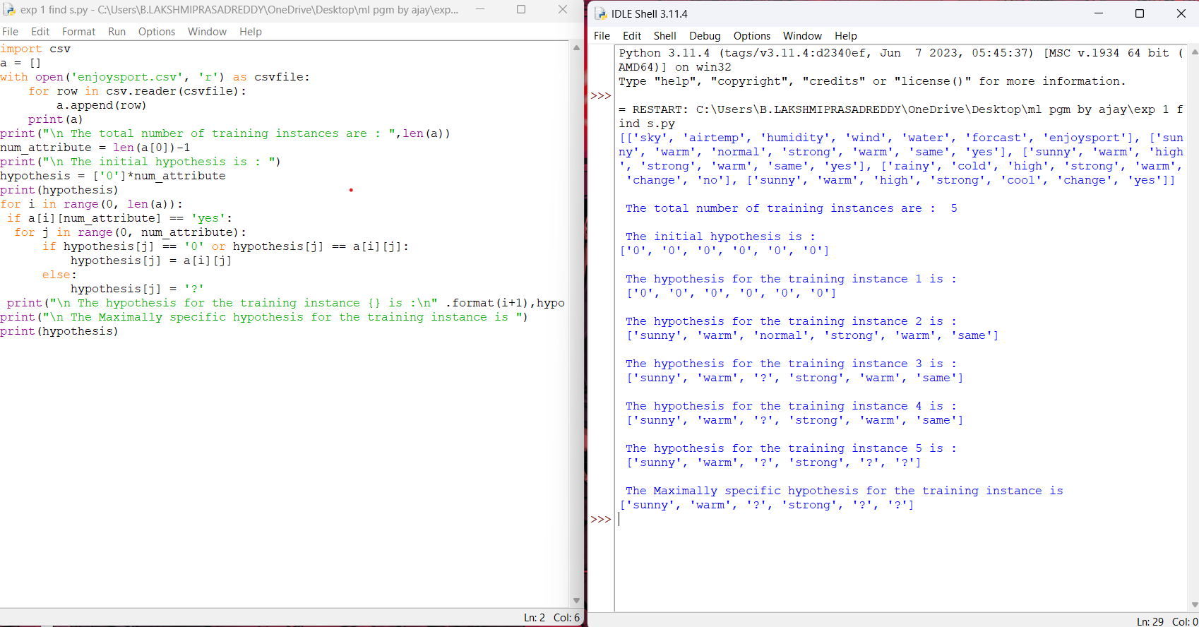

1. For a given set of training data examples stored in a .CSV file, implement and demonstrate the Candidate-Elimination algorithm in python to output a description of the set of all hypotheses consistent with the training examples

Output:

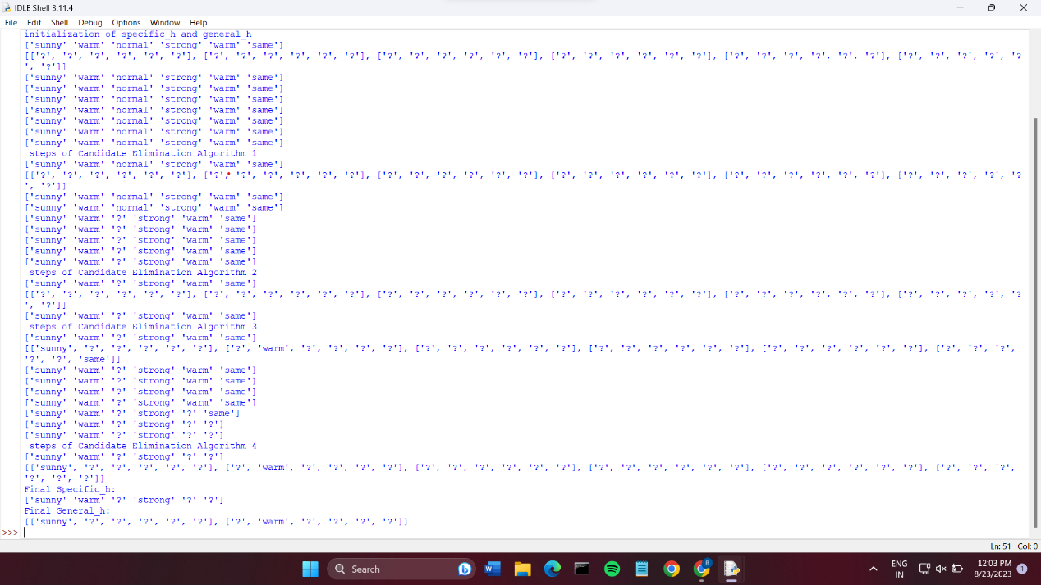

1. Demonstrate the working of the decision tree based ID3 algorithm. Use an appropriate data set for building the decision tree and apply this knowledge to classify a new sample.

Output:

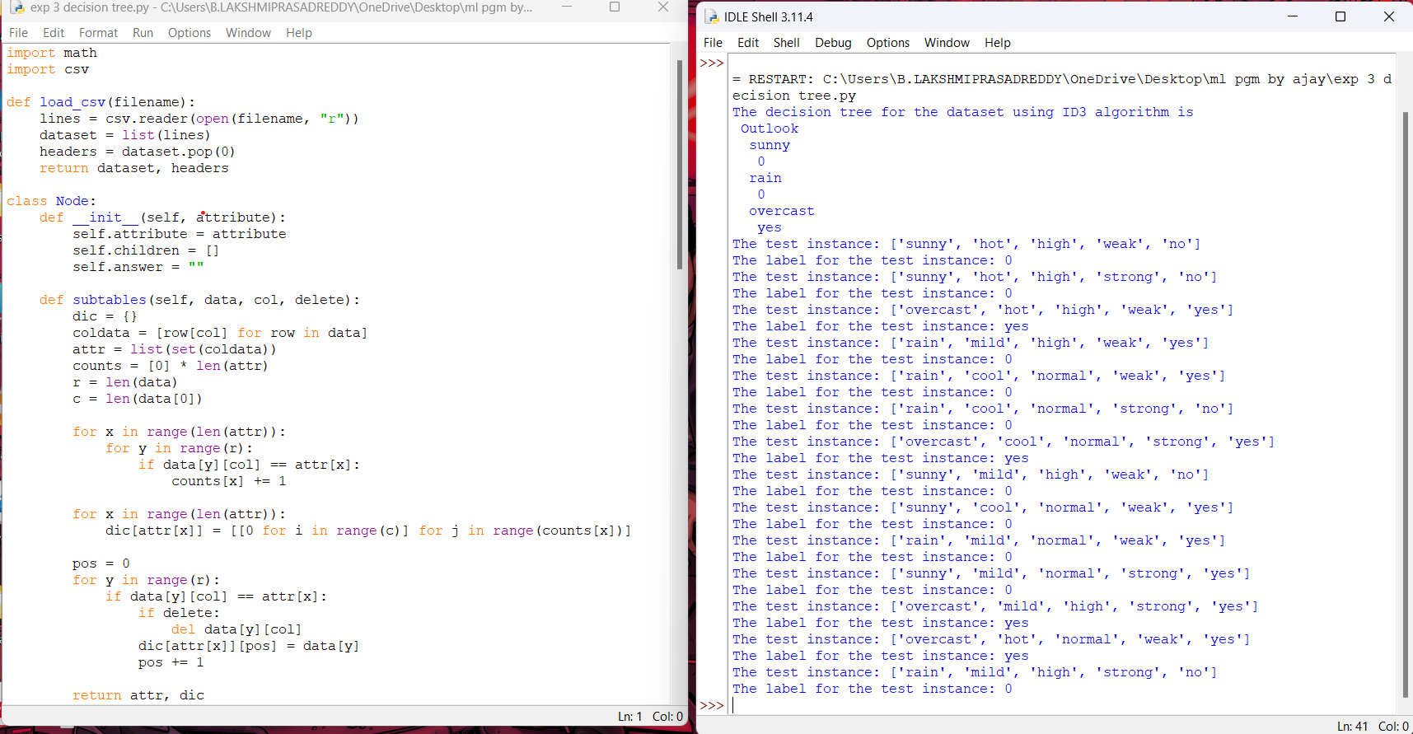

1. Build an Artificial Neural Network by implementing the Backpropagation algorithm and test the same using appropriate data sets.

Output:

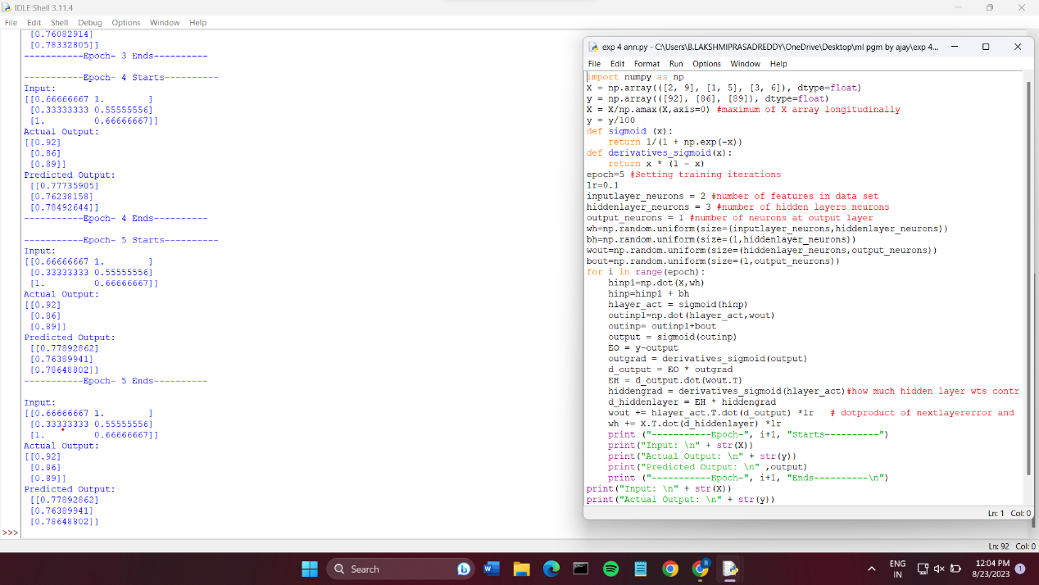

1. Write a program for Implementation of K-Nearest Neighbours (K-NN) in Python

Output:

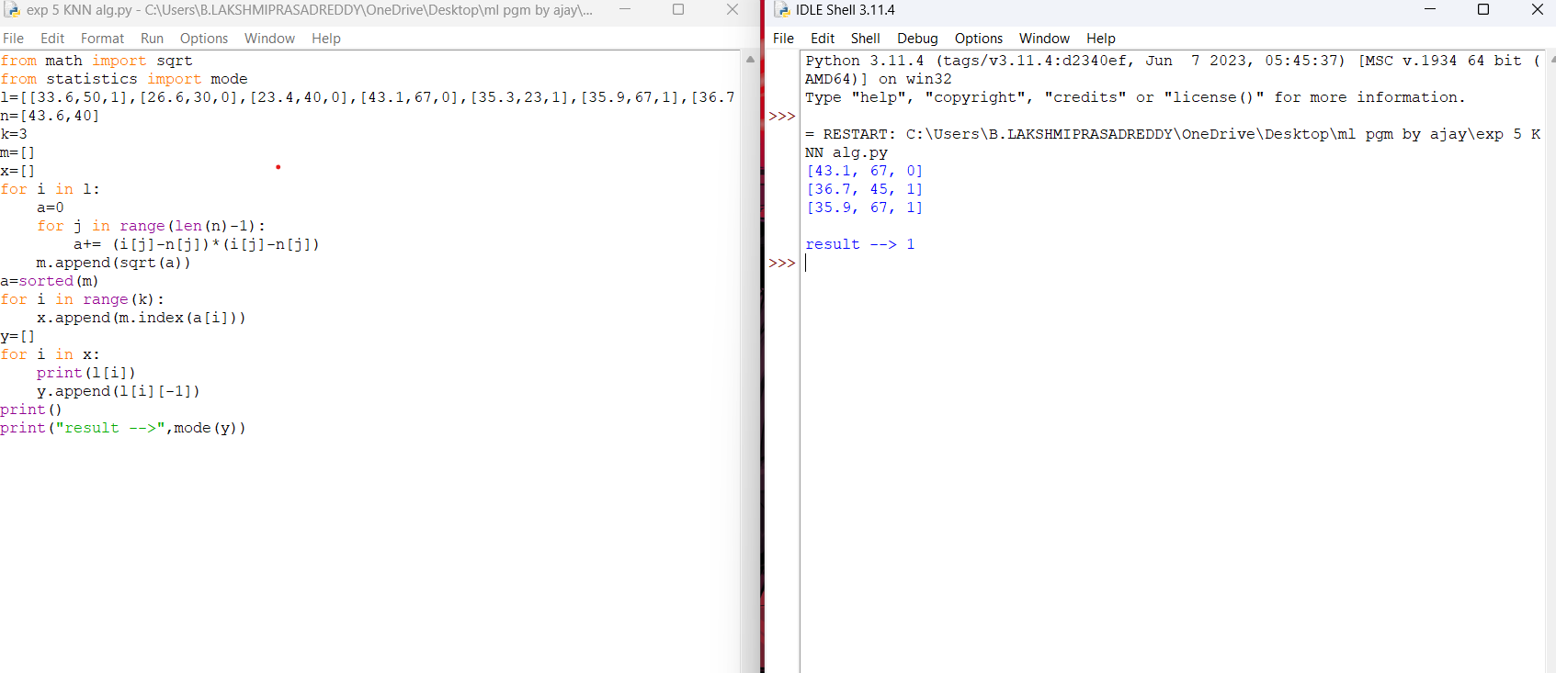

1. Write a program to implement Naïve Bayes algorithm in python and to display the results using confusion matrix and accuracy.

Output:

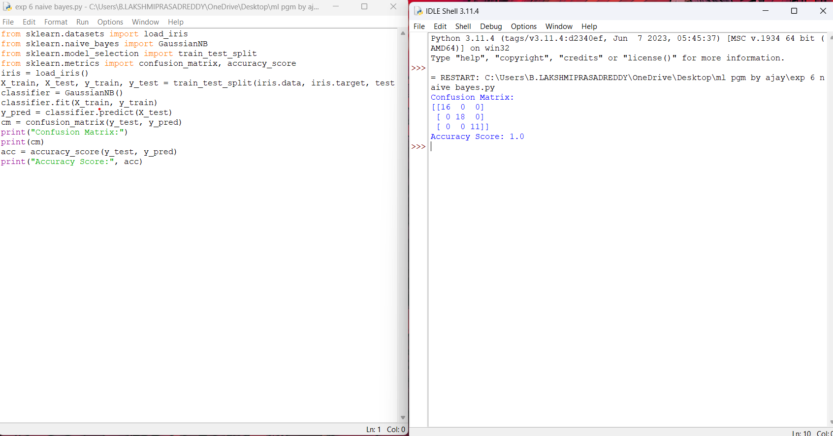

1. Write a program to implement Logistic Regression (LR) algorithm in python

Output:

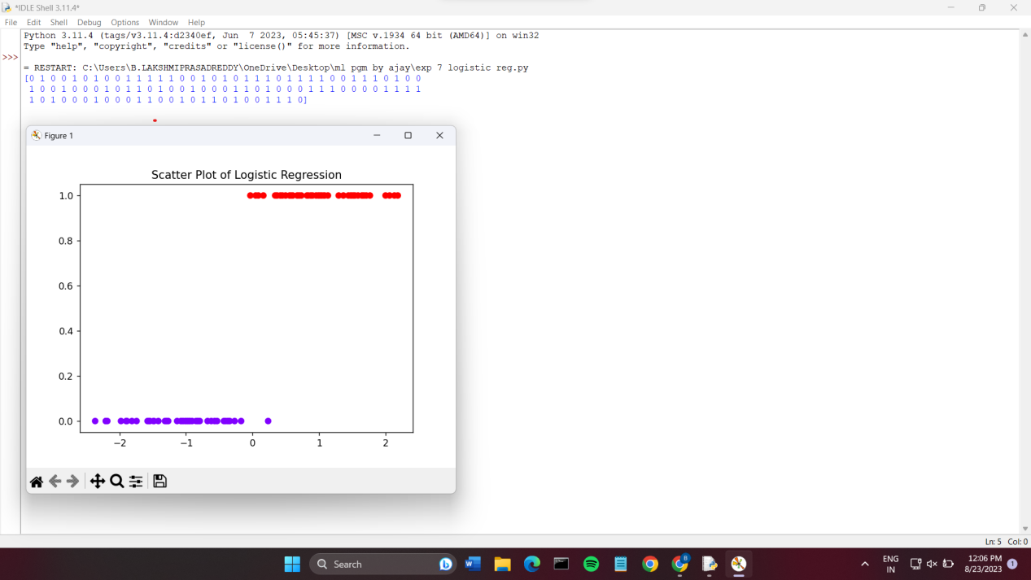

1. Write a program to implement Linear Regression (LR) algorithm in python

Output:

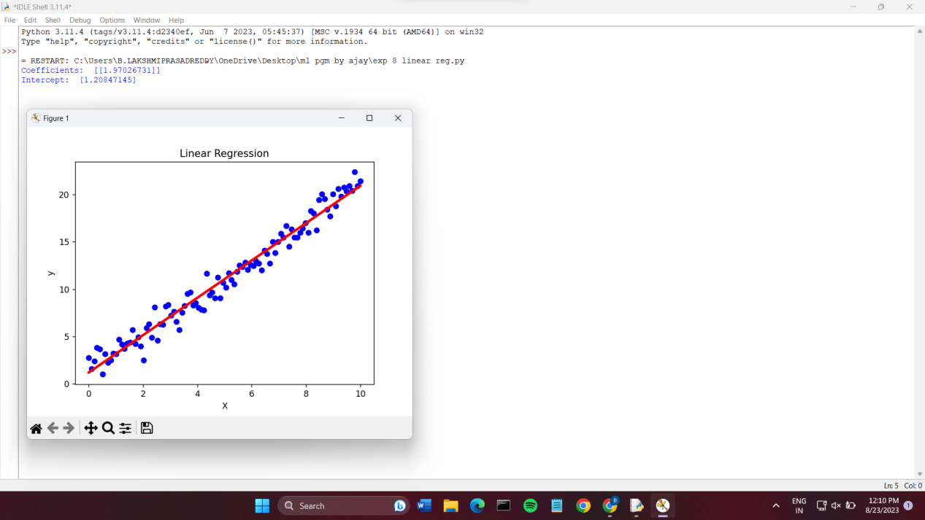

1. Compare Linear and Polynomial Regression using Python

Output:

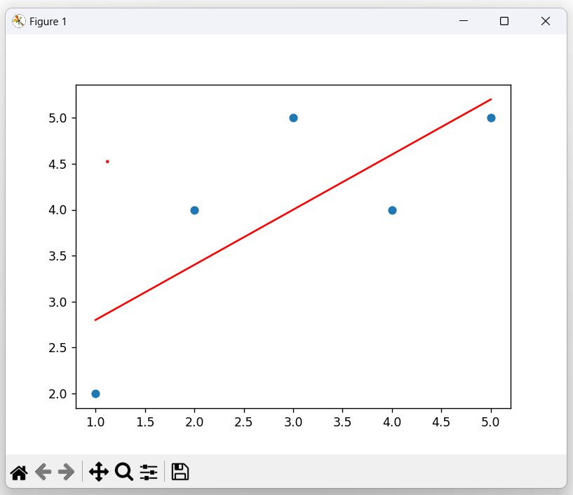

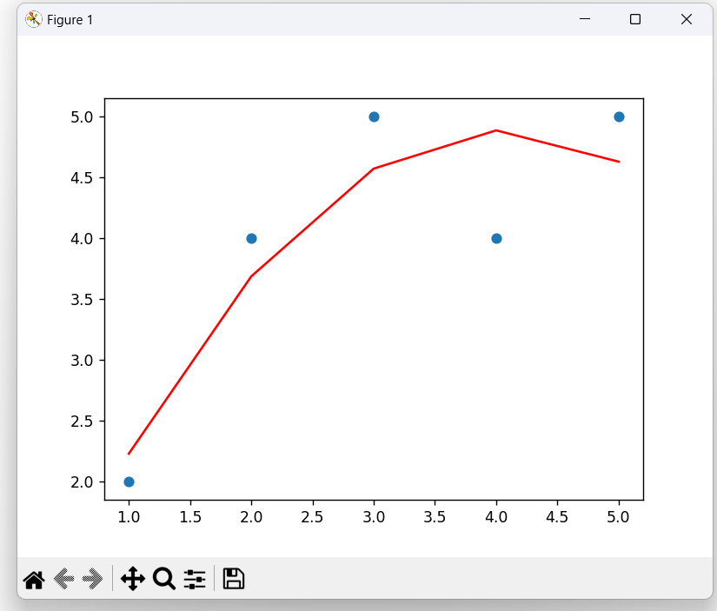

1. Write a Python Program to Implement Expectation & Maximization Algorithm

Output:

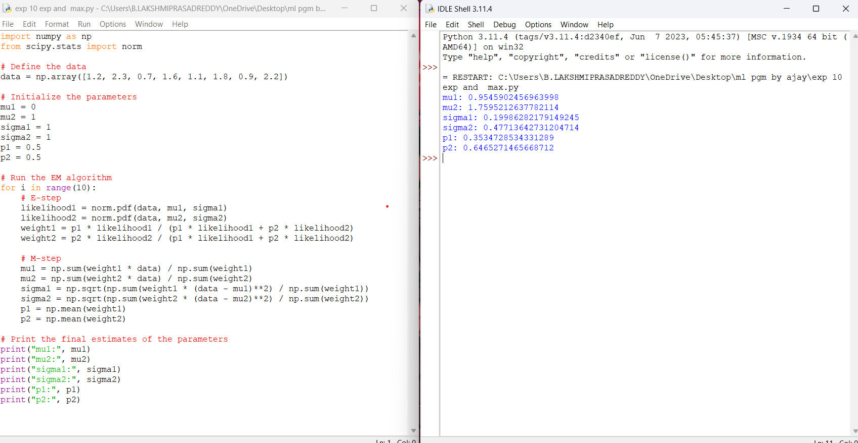

1. Write a program for the task of Credit Score Classification

Output:

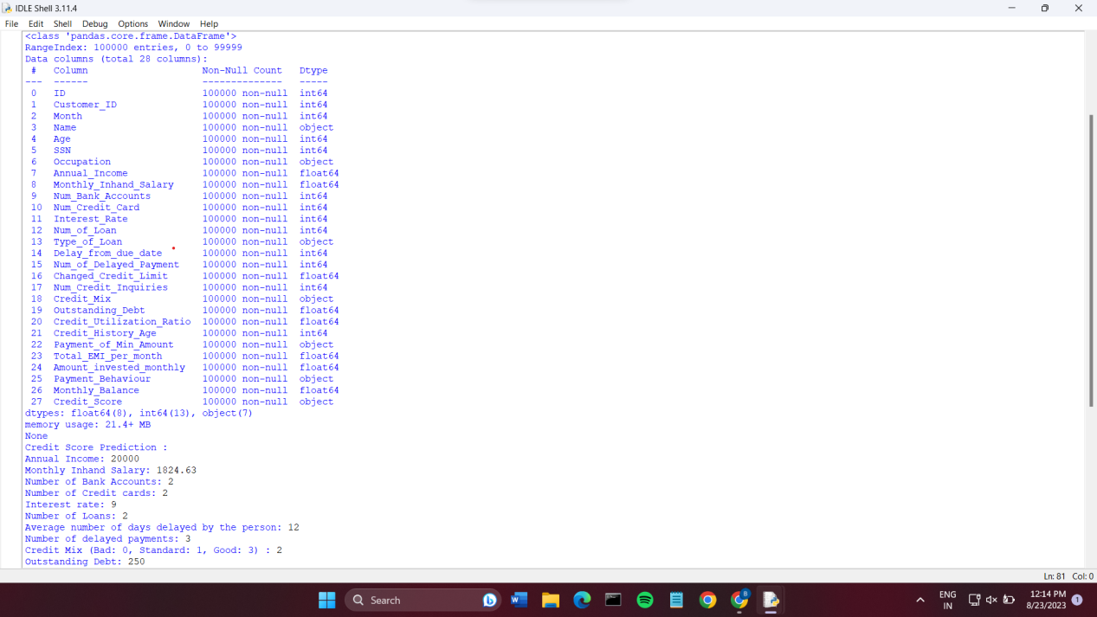

1. Implement Iris Flower Classification using KNN

Output:

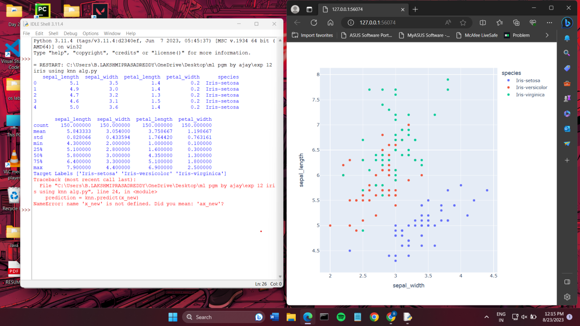

1. Implement the Car Price Prediction Model using Python

Output:

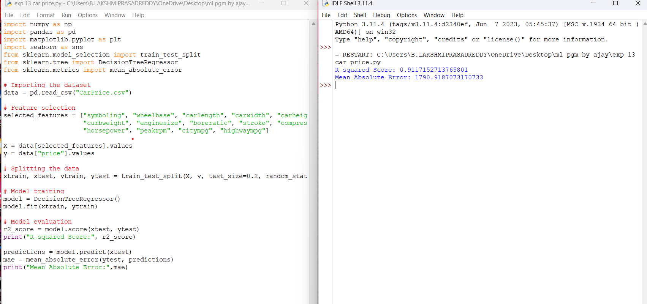

1. Implement House price Prediction using appropriate machine learning algorithm

Output:

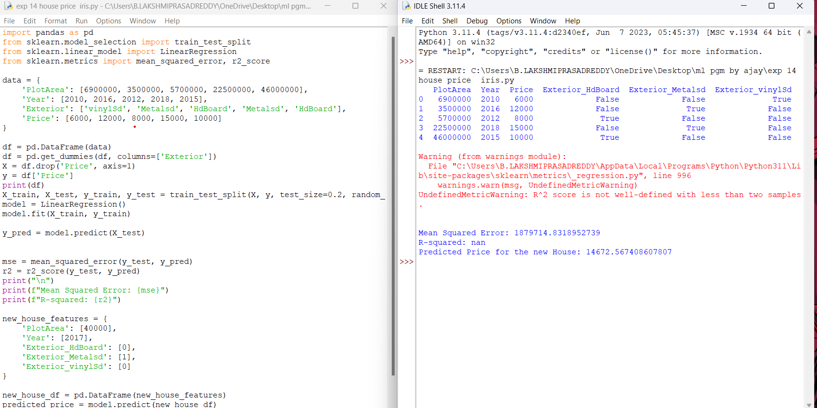

1. Implement Iris Flower Classification using Naive Bayes classifier

Output:

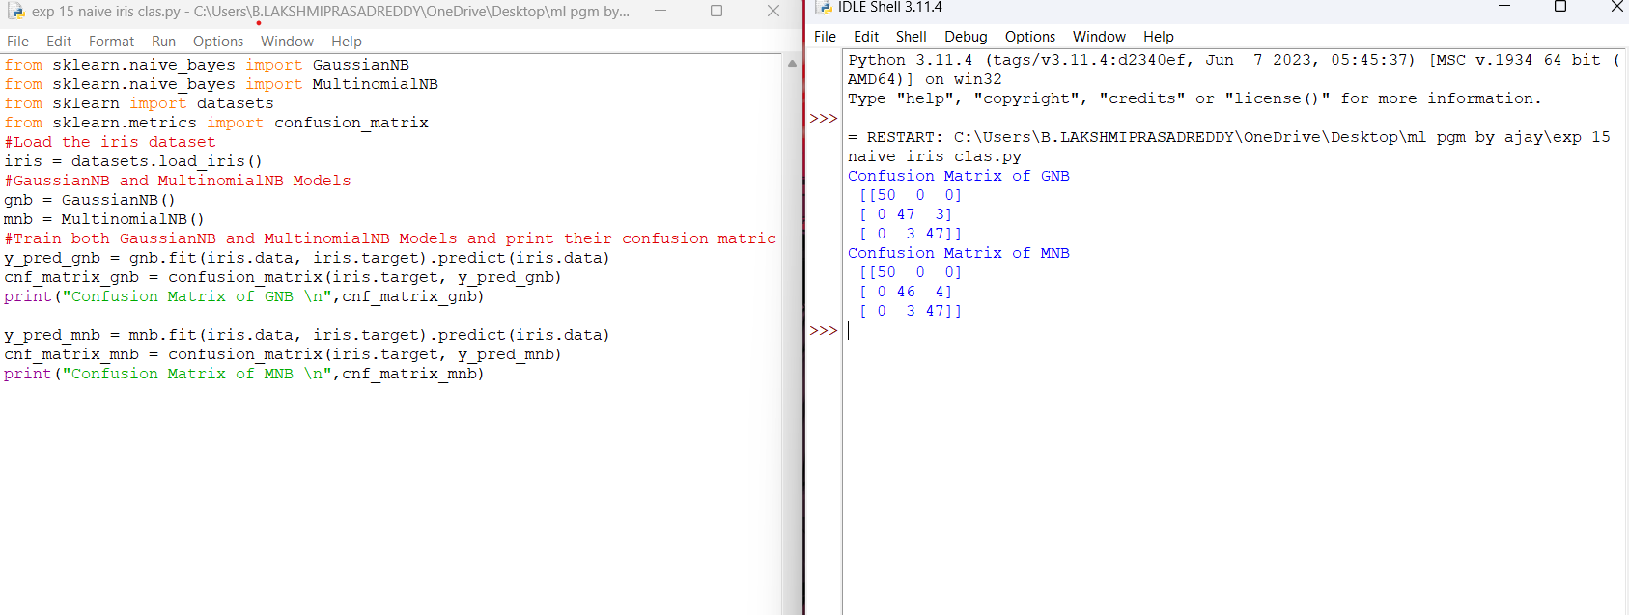

1. Compare different types Classification Algorithms and evaluate their performance.

Output:

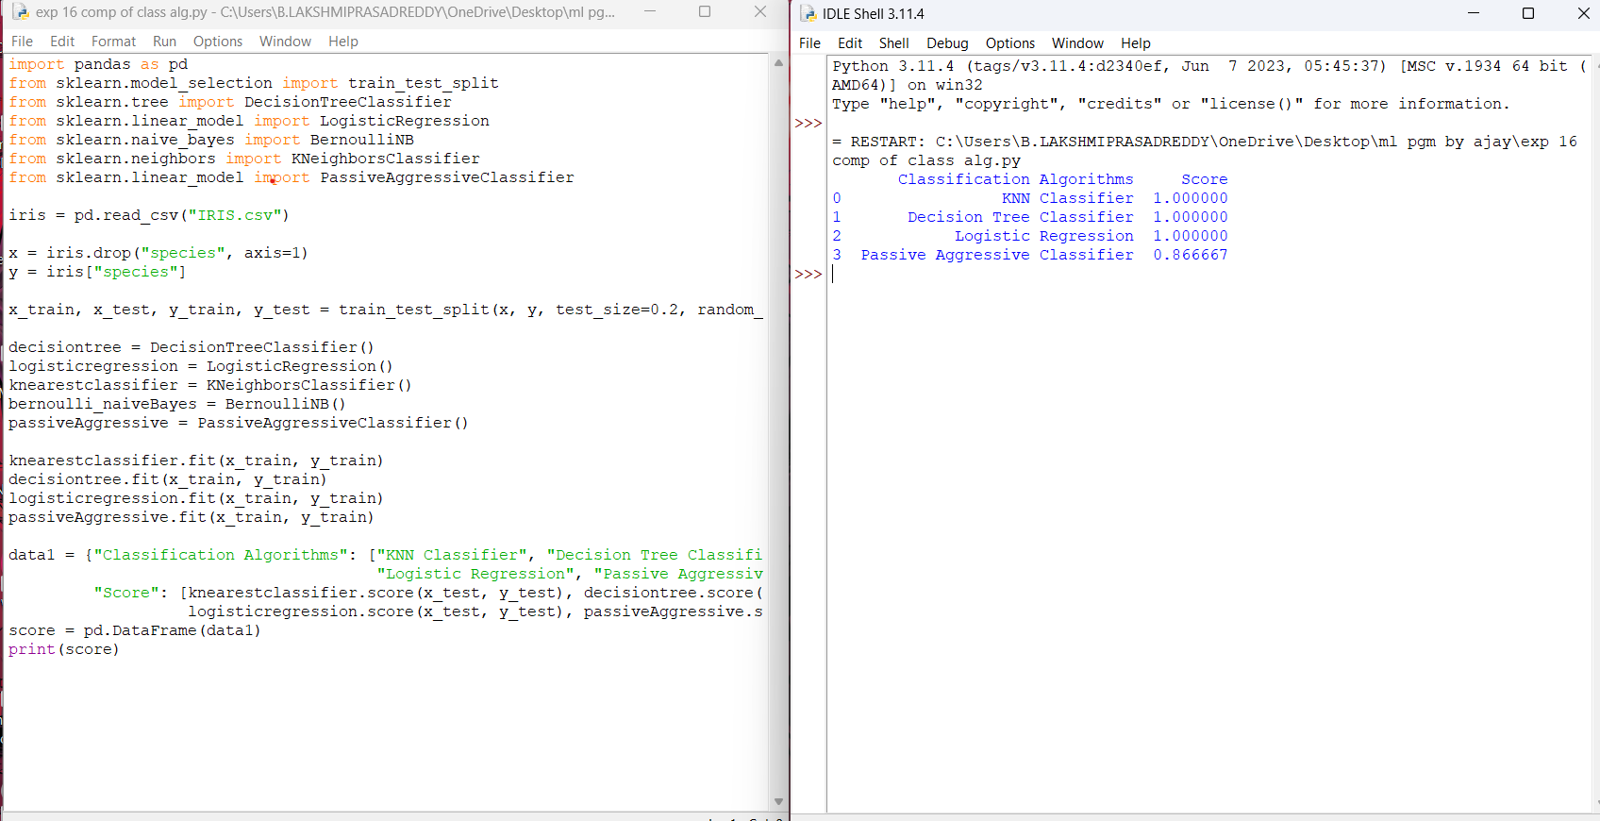

1. Implement Mobile Price Prediction using appropriate machine learning algorithm

Output:

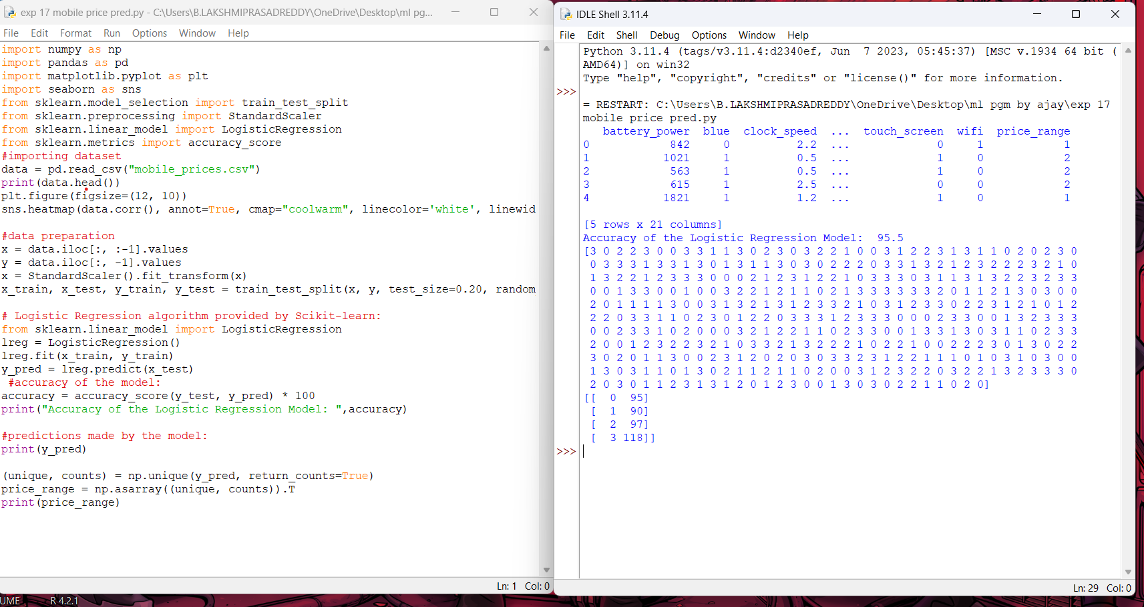

1. Implement Perceptron based IRIS classification

Output:

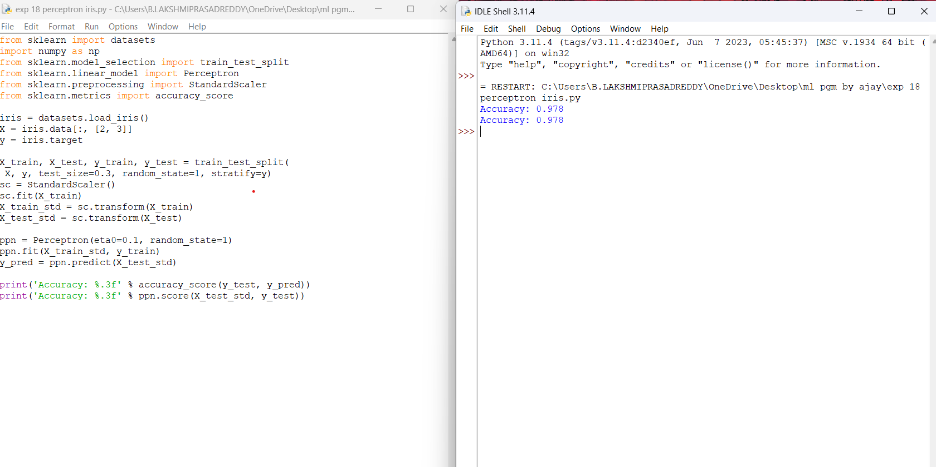

1. Implementation of Naive Bayes classification for Bank Loan prediction

Output:

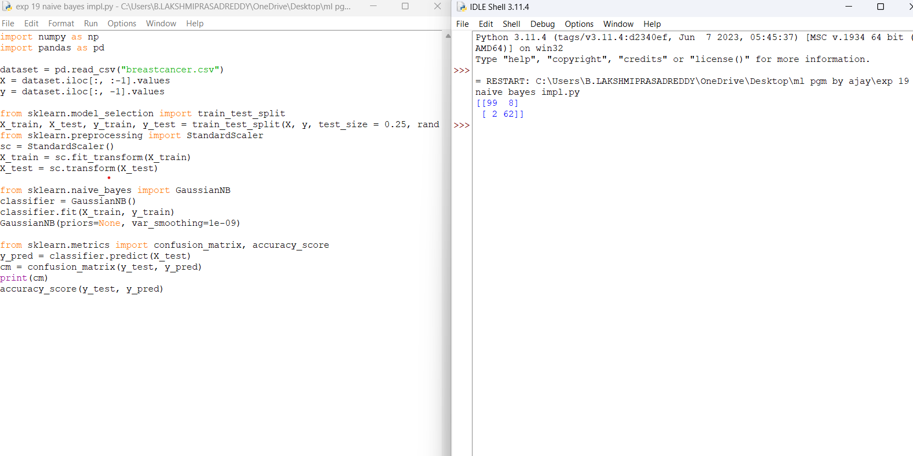

1. Implement Future Sales Prediction using a suitable machine learning algorithm

Output:

